**Edge detection robot using BO motor**

Introduction

Active IR sensor is used in this project to sense the edges. It consists of two elements: The IR transmitter and IR receiver. Basically, the IR transmitter emits the Infrared rays, the rays hit the obstacle and bounces back which is received by the IR receiver. Based on the intensity of the received signal the object distance is found. In our project when the robot detects an edge the intensity of the received IR rays will be very low so the robot will actuate accordingly by avoiding the edges.

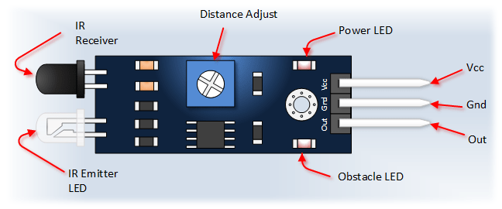

Components

Arduino uno

IR sensor

BO motor

Application

 it is widely used in fields such as military, space exploration, manufacturing industries, self-driving cars, industrial robots, rovers

Objective

**During this activity ,you will help students to achieve following objectives**

**1.** Understanding the principle and operation of IR sensor

2. Design algorithm and flowchart for edge detection using IR senor

3. Programming IR sensor module using Arduino uno

4. Interfacing IR sensor Module with Arduino uno

Programming steps

1. Initialize motor and LED as output port
2. Initialize IR sensor as input port
3. Initialisevariable to read values.
4. Read sensor input values
5. if(SrV==LOW && SlV== LOW) then move motor in forward direction&LED OFF
6. if(SrV==HIGH && SlV== HIGH) then move motor in reverse direction&LED on

Program

int lm1=8; //left motor output 1

int lm2=9; //left motor output 2

int rm1=10; //right motor output 1

int rm2=11; //right motor output 2

int sl=13; //sensor 1 input (left)

int sr=12; //sensor 2 input (right)

int SlV=0;

int SrV=0;

int led=A0;

void setup()

{

pinMode(lm1,OUTPUT);

pinMode(lm2,OUTPUT);

pinMode(rm1,OUTPUT);

pinMode(rm2,OUTPUT);

pinMode(led,OUTPUT);

pinMode(sl,INPUT);

pinMode(sr,INPUT);

sTOP();

}

void loop()

{

SlV=digitalRead(sl);

SrV=digitalRead(sr);

if(SrV==LOW && SlV== LOW)

{

digitalWrite(led,LOW);

ForWard();

}

if(SrV==HIGH && SlV== HIGH)

{

digitalWrite(led,HIGH);

BackWard();

delay(400);

Right();

delay(550);

ForWard();

delay(200);

}

if(SrV==LOW && SlV== HIGH)

{

digitalWrite(led,HIGH);

BackWard();

delay(400);

Right();

delay(550);

ForWard();

delay(200);

}

if(SrV==HIGH && SlV== LOW)

{

digitalWrite(led,HIGH);

BackWard();

delay(400);

Left();

delay(550);

ForWard();

delay(200);

}

}

void ForWard()

{

digitalWrite(lm1,HIGH);

digitalWrite(lm2,LOW);

digitalWrite(rm1,HIGH);

digitalWrite(rm2,LOW);

}

void BackWard()

{

digitalWrite(lm1,LOW);

digitalWrite(lm2,HIGH);

digitalWrite(rm1,LOW);

digitalWrite(rm2,HIGH);

}

void Left()

{

digitalWrite(lm1,LOW);

digitalWrite(lm2,HIGH);

digitalWrite(rm1,HIGH);

digitalWrite(rm2,LOW);

}

void Right()

{

digitalWrite(lm1,HIGH);

digitalWrite(lm2,LOW);

digitalWrite(rm1,LOW);

digitalWrite(rm2,HIGH);

}

void sTOP()

{

digitalWrite(lm1,LOW);

digitalWrite(lm2,LOW);

digitalWrite(rm1,LOW);

digitalWrite(rm2,LOW);

}

Hardware instruction

1. Chassis of the robot is build using the motors and the sensors.
2. Connect the IR sensors to the PIN13and 12 of the Arduino board where Arduino takes input from the sensor
3. connect the motor driver output to motor according to VCC and GND supply
4. Connect motor driver to Arduino such that

IN1 = PIN11

IN2=PIN 10

IN3=PIN 9

IN4=PIN8

1. After the connection is done the required code is written
2. Coonect LED anode at A0 and cathode at gnd

